Director: David Yates
Yates has directed a variety of media, he started out in short film and has done TV series, documentaries and mini-series, and TV movies before landing his place directing Harry Potter from The Order of the Phoenix (5) to Deathly Hallows Part 2 (8). He has since directed The Legend of Tarzan (2016) before reuniting with the Wizarding World to direct Fantastic Beasts and Where to Find Them.

Costume Designer: Colleen Atwood
Atwood is a Oscar winning designer who is best known for her work on Silence of the Lambs (1991), Big Fish (2003) and the TV series Arrow (2012), she is also known for her collaborations with Tim Burton on films such as Sweeney Todd: The Demon Barber of Fleet Street (2007), Edward Scissorhands (1990) and Alice In Wonderland (2010) and Alice Through the Looking Glass (2016). This is her first time designing for the Wizarding World.

(Info credited to IMDb)
Scene 1:
The setting is 1920’s New York. Newt Scamander has just arrived off a boat and is at security checks, he flicks a switch on his case making it ‘Muggle worthy’ so the guard doesn’t find all the magical creatures living inside.
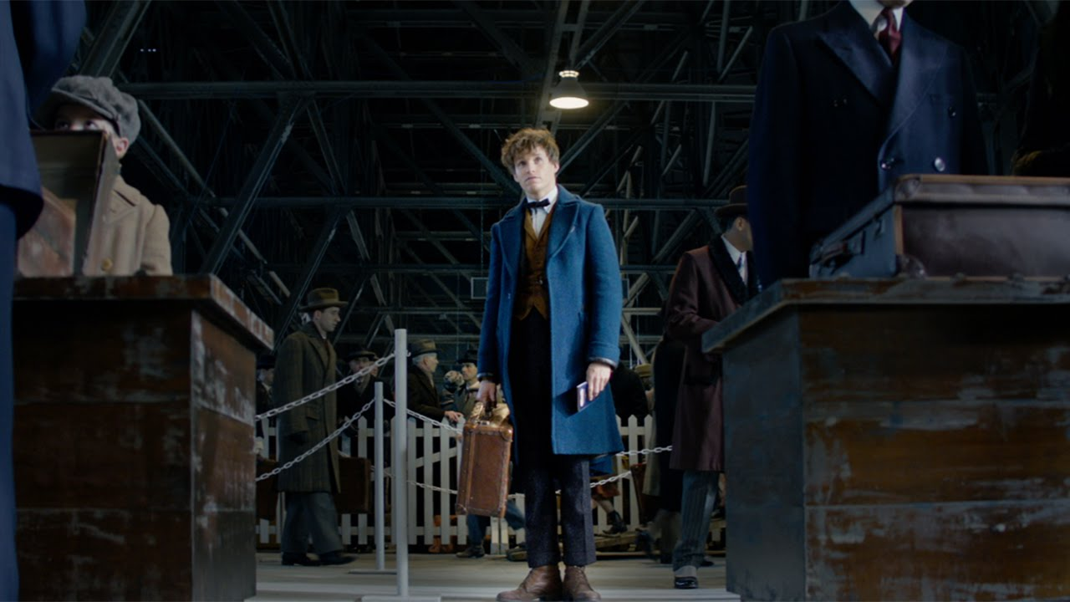
-Newt; is wearing a teal blue wool coat and a mustard yellow waistcoat, making him stand out subtly from all the extras wearing neutral colours. The waistcoat may show his Hogwarts house of Hufflepuff. The clashing bright colours show his awkwardness around people, like he doesn’t know how to style clothes so tries to copy everyone else, he is more himself around his creatures. The coat is loose to give fluidity and freedom of movement, and ill-fitting enough to give a quirky edge.

Scene 2:
Newt is being transported to MACUSA (Magical Congress of the United States of America) by Porpentina Goldstein, an (ex) Auror, after one of his creatures, a Niffler, got loose in a bank and he caused quite a bit of disruption getting him back.

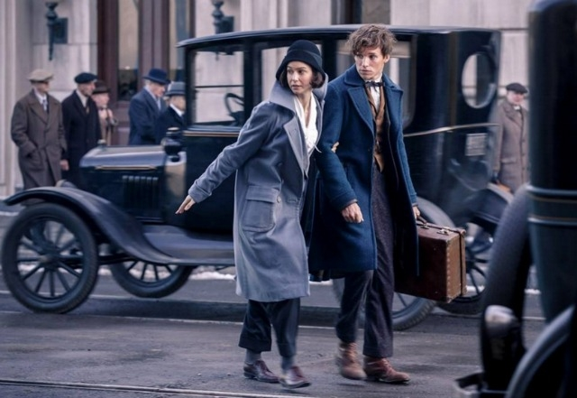
-Porpentina; wears monochrome colours, showing she is all business, a career girl. Her coat has an oversized lapel/collar giving her the look of a classic detective, putting her in authority in this scene, and her trousers are shapeless, showing she dresses more masculine to be taken seriously.

Scene 3:
Porpentina and her sister Queenie enter the bedroom to realise Newt and Jacob (muggle who was bitten by one of Newts creatures) have gone.

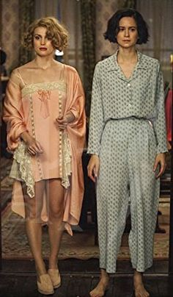
-Porpentina; is wearing button down pyjamas, with the shirt tucked into the trousers, giving her a more masculine look even in her night clothes. They are simple clothes with no adornment showing she doesn’t care for looking good she wants to do her job.
-Queenie; is wearing a pink nightie adorned with lace trim and a bow, under a matching silk dressing gown, this shows her to be a feminine character who takes care in her appearance. Pink also symbolises sympathy, which she has a lot of as we learn she is a Legilimens (she can read minds) so cannot help but connect to people and see what they are going through.

Scene 4:
Porpentina catches Newt in his case and takes him before the MACUSA council as they are discussing the killing of the New York senator by a magical being. Once Tina tells them Newt has a cast full of magical creatures and some have escaped they blame him for the senator’s death and impound the case and arrest him, Jacob and Tina.
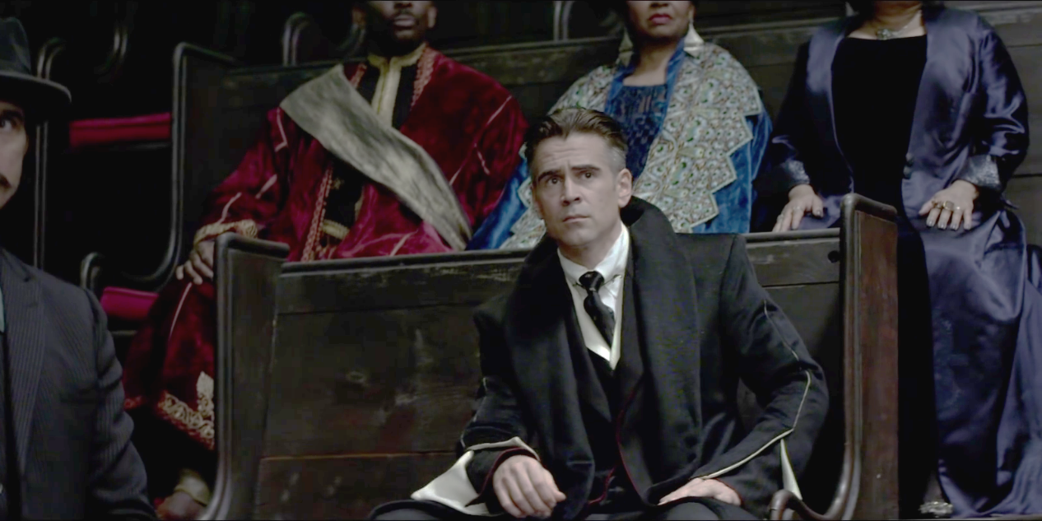
-Percival Graves wears a black suit with white lining. The costume gives him presence and elegance and the dramatic white lining gives him a sense of power and sets him apart from the other witches and wizards on the council who wear coloured clothes. The weight of the coat means it flows when he moves and the shoulders are slightly exaggerated. The white beneath the black coat may also foreshadow that it is actually Grinderwald in disguise as Graves, as Grinderwald’s hair is white. The costume has a touch of glamour which shows his position and importance within MACUSA.

Scene 5:
Newt, Tina, Queenie and Jacob are in a jazz club looking to speak to an informant to find signs of the the creature ‘Doogle’, a Demiguise, from Newt’s case. Queenie and Jacob have a drink while Tina and Newt question the informant.
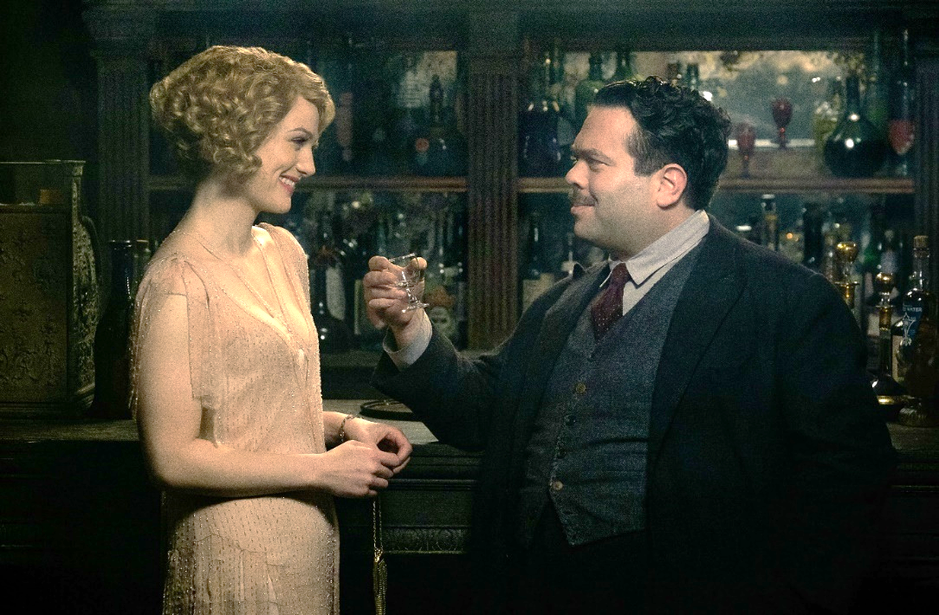
-Queenie; is wearing a peach coloured jazz dress made of a light beaded chiffon, the colour is warm, light and feminine, matching her character and making her look approachable and friendly. This also shows that she is warming up to Jacob and exhibits their chemistry.
-Jacob; is wearing a dark wool suit with a mismatched grey waistcoat with mismatched buttons, showing it has been repaired a lot. The suit looks a little drab and shows how he is different from the wizards that surround him, giving him an air of humility and humanity to anchor him to reality as he is catapulted into this fantastical secret world.

(Images credited to Warner Bros. Pictures/ David Yates, Colleen Atwood)

