Director: Josh Boone
Boone is a writer and director, He has written and directed Stuck in Love (2012) and directed The Fault in our Stars (2014). He is also writing and directing the upcoming movie X-Men: The New Mutants (2018) which is currently in pre-production.

Costume Designer: Mary Claire Hannan
Hannan started her career as a costume supervisor for Reservoir Dogs (1992) and was also assistant costume designer for Pulp Fiction (1994). She has since designed for films such as Jackie Brown (1997) and Serendipity (2001). She has worked on John Green stories twice; first with The Fault in our Stars and also Paper Towns (2015).
(Info credited to IMDb)
Scene 1:
The setting is outside a church group. Hazel has just been to her support group for cancer patients and meets a boy called Augustus Waters. They stand outside as Hazel waits for her mother to pick her up.
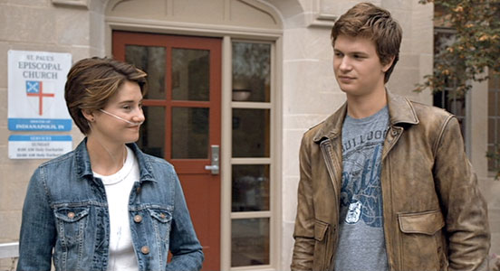
-Hazel Grace Lancaster; is wearing a blue denim jacket, blue has the colour connotation of depression, which her mother worries she has at this point in the story. She is also wearing a plain white t-shirt and grey joggers, she didn’t put much thought or effort into her outfit, possibly signalling that she has depression.
-Augustus Waters; is wearing a grey basketball team t-shirt, showing he may be a sports fan, under a vintage looking brown leather jacket. Brown symbolises support, dependability and protection, suggesting that he could help Hazel. The vintage look makes him look experienced, showing he is perhaps older than Hazel and visualising that he is an “old hat” at cancer and battling it, which we have just learned in the previous scene.

Scene 2:
Hazel is upset because she is too sick to fly to Amsterdam to meet her favourite author, she is overwhelmed with the life she has and Augustus (Gus) comes over to see this sad, lonely swing set she is looking at in her back garden and talk to her. He tells her he has feeling for her and she explains that she wants to minimalize the people she hurts when she eventually dies so she cannot let the relationship go on further.

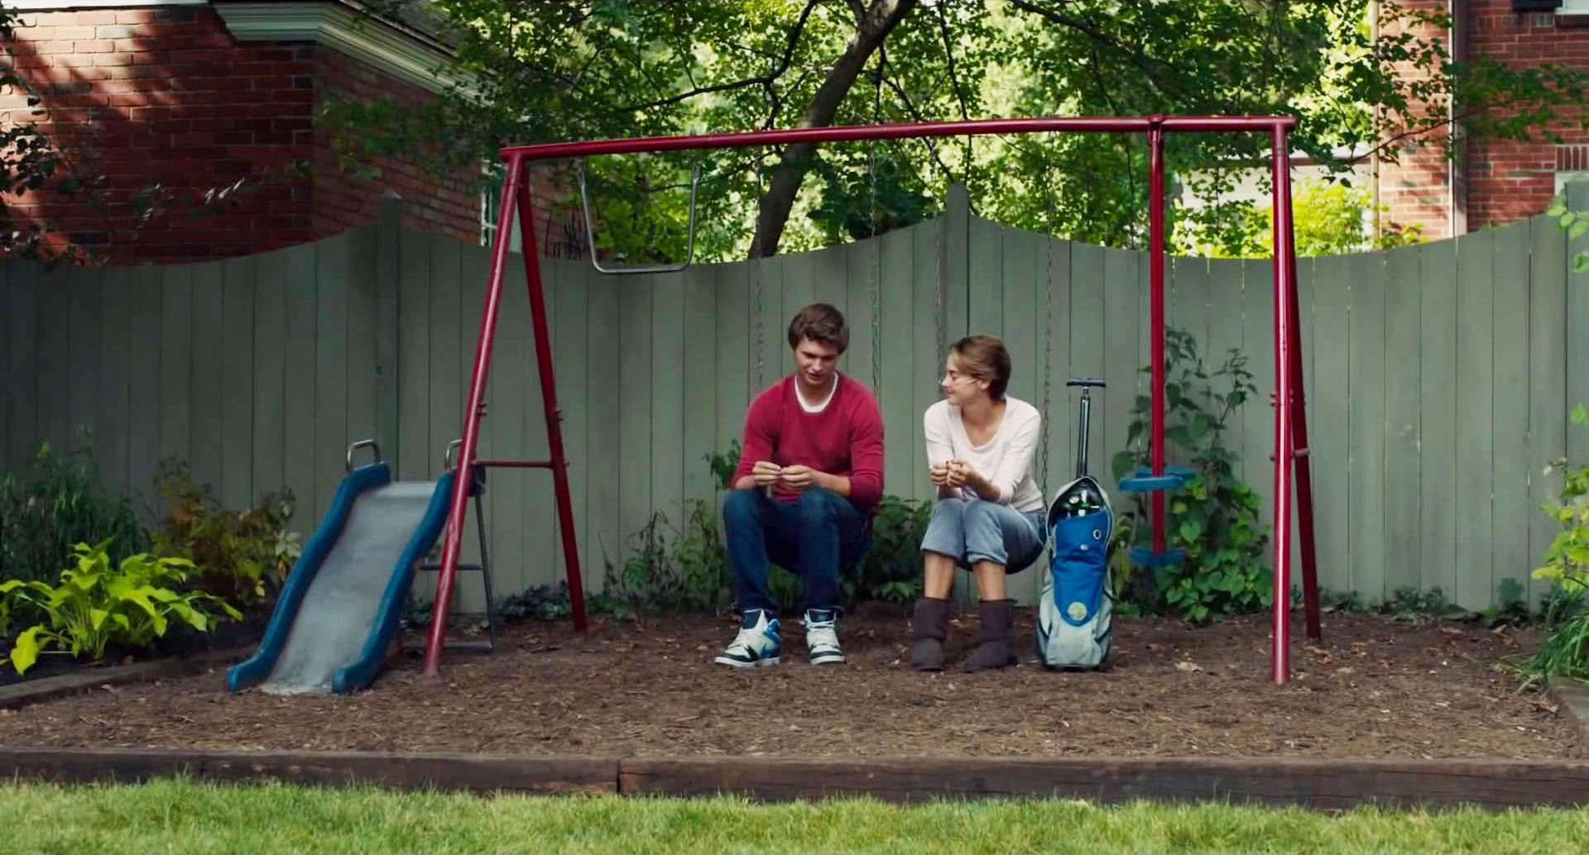
-Gus; is wearing red and blue, the same colours as the swing set. Showing Hazel is sad for him and sad (she feels) she can’t get close to him because he will be left behind like the swing set.
The red may also symbolise his growing passion and affection for Hazel.
-Hazel; is wearing a plain white t-shirt and grey joggers, white can symbolise fearfulness, the thought of hurting those she leaves behind scares her. Also the grey shows she is trying to be conservative with her emotions so to minimalize Gus’ pain in the end. The comfy choice of clothes shows she is at home (as in location) and comfortable around Gus now. She doesn’t feel the need to dress up for him.

Scene 3:
Hazel and Gus do make it to Amsterdam in the end and are out to dinner together. They drink champagne and Gus tells Hazel he is in love with her.

-Gus; is wearing a black suit and tie with a blue shirt that compliments Hazel’s dress, showing them as a pair even though Hazel still won’t let the relationship develop. The black suit foreshadows where the illness will eventually take them.
-Hazel; is wearing a blue dress her mother bought for her for the date. It is flattering but modest as it is figure hugging but with a high neckline. The continuing use of blue shows how they cannot escape their illness but also how it is a part of them and their life and how they live with it and carry on.

Scene 4:
Gus’ cancer has returned with a vengeance and he is slowly dying. He calls Hazel one night telling her to find him at a gas station because something feels wrong. Hazel goes to the gas station to help Gus who had tried to drive himself there and buy cigarettes, but he had caught an infection so she needed to call 911 for him. Gus is severely distraught and depressed at this point as he wanted to be able to do one thing for himself but the cancer has taken his ability to do that.

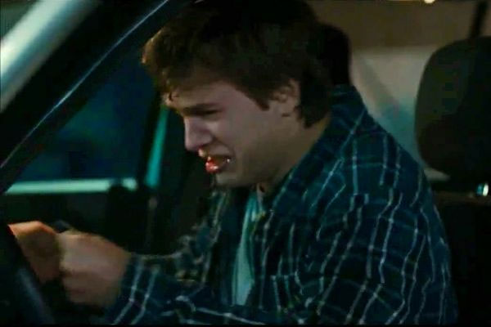
-Gus; is now the one wearing blue, showing the situation has flipped and he is now the one who is struggling and depressed and in need of help, this shows how cancer changes and affects a person. This is the first time he is not wearing his brown leather jacket since he was re-diagnosed, showing his vulnerability. He does not wear it again.

Scene 5:
Hazel is in bed and receives the message that Gus has passed away. Her parents come in to comfort her while she cries.

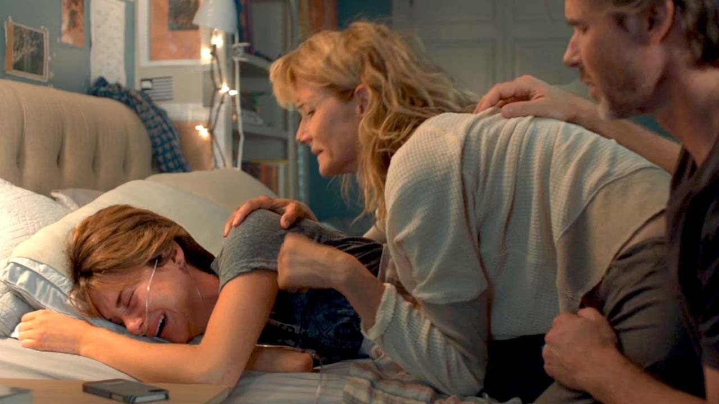
Her parents are wearing grey and white, symbolising loss and perhaps peace, as Gus is no longer suffering. The soft fabrics show they want to comfort her.
-Hazel; is wearing the basketball t-shirt Gus wears the first time she meets him. This shows her deep relationship with him and reminds the viewer of the person she has lost. Grey also has the connotation of loss.

(Images credited to Fox 2000 Pictures/ Josh Boone, Mary Clair Hannan)

