  Rachel  Wainwright | Contact Details  rachelwainwright.costume@gmail.com  www.rwdigitalportfolio.weebly.com  https://rachwainwright.wixsite.com/mysite
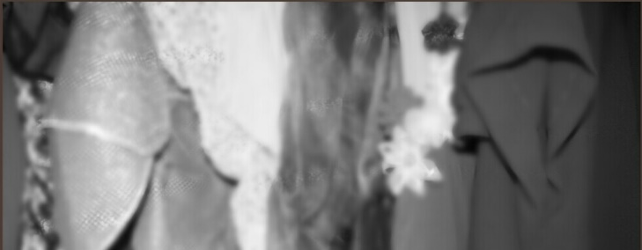
Objective
Skills
- Organisation
- Design illustration (analogue, some Photoshop)
- Contextual research
- Dressing
- Some garment construction skills
- Styling
- Hand embroidery

My goal is to work within the costume department of the theatre or film industry. I have always had a passion for stories, whether they are books, films or theatre productions, and would love to be a part of bringing those stories to people via clothing.

Experience

Dresser- The Alexandra- Motown UK tour

4th October- 3rd November 2018

Wardrobe Assistant- New Alexandra Stage Experience 2018- Boogie Nights

10th- 25th August 2018

Head of Running Wardrobe- AUB Production- Fermented Honey

14th- 21st May

Wardrobe Daily- Web Series- Shelley

27th March 2017

Dresser- AUB Production- As If

21st-23rd November 2017

Dresser- AUB Production- The Visit

16th-21st October 2017

Wardrobe Assistant- New Alexandra Stage Experience 2017- West Side Story

11th- 26th August 2017

Wardrobe Assistant- Short Film- Impersonation

27th-28th April 2017

Costume Designer- AUB Short Film- Where the Sky and Water Meet

14th-15th February 2017

Costume designer- AUB Short Film- Legerdemain

7th-10th February 2017

Wardrobe Assistant- New Alexandra Stage Experience 2016- GREASE

August 2016

Wardrobe Assistant- Birmingham Royal Ballet- Far From the Madding Crowd

17th- 22nd June 2012

Education

BA (Hons) Costume and Performance Design

Arts University Bournemouth: Sept 2015- June 2018
Second Class Honours Upper Division (2:1)

Level 3 Art and Design BTEC- Theatre, Film, and TV

Sutton College: Sept 2013- June 2105
Merit

GCSEs x12

Barr Beacon School: Sept 2008- July 2013
Personal/ Social/ Development- ASDAN- Pass, Art-BTEC- D*, Biology- GCSE- B, Chemistry- GCSE- B, Physics- GCSE- C, English- GCSE- B, English Literature- iGCSE- B, History- GCSE- B, IT OCR- ONAT- Distinction, Mathematics- GCSE- B, Spanish- GCSE- C, Textiles-GCSE-A*

References

Jane Griffiths

Head of Wardrobe- New Alexandra Stage Experience
griffiths119@aol.com 07753 222762

Emma Buet

Personal Tutor- L3 Theatre, Film, and TV
Emma.buet@bmet.ac.uk

Bunny Winter

Tutor- Costume Design for Screen- AUB
bwinter@aub.ac.

